SPORTS INTERNSHIP OPPORTUNITY
Account Executive/Ticket Sales Internship
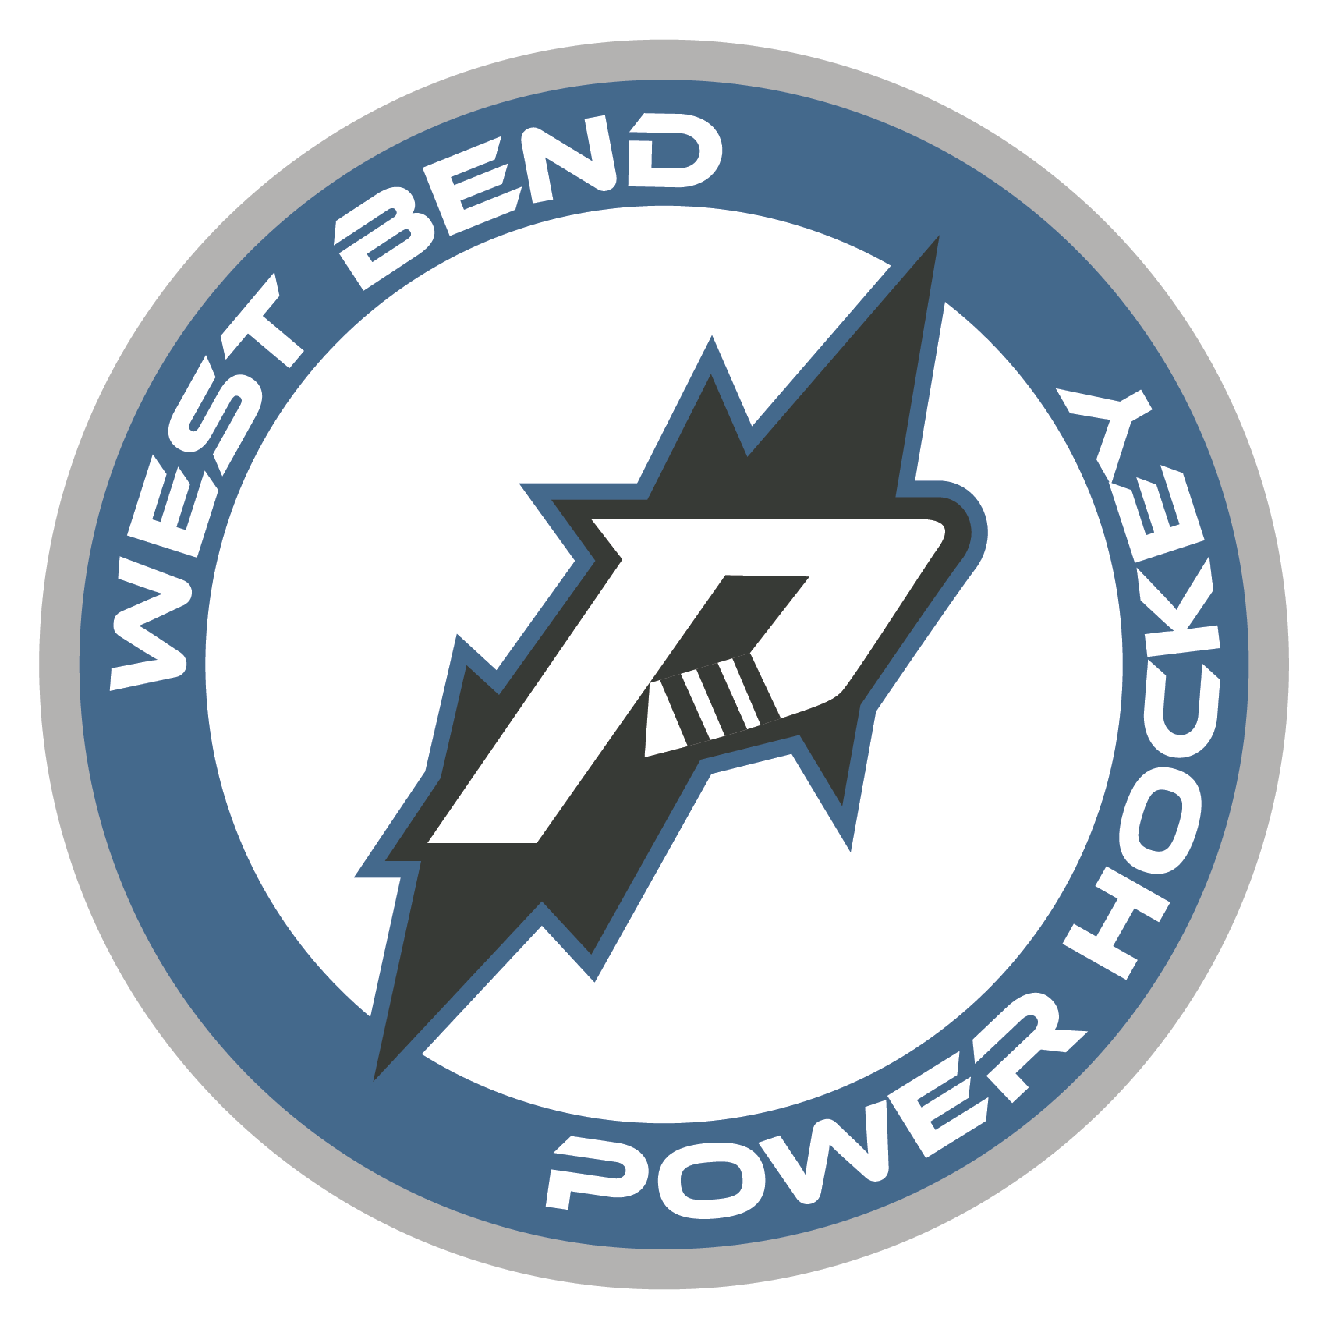
West Bend Power, North American 3 Hockey League Part Time & Full Time
Offseason (May-Sept) Half-Season (Sept-Dec; Jan-May) Full Season (Sept-May)
The West Bend Power Hockey Organization is looking for motivated, passionate interns to assist with operations during the 2024-2025 season. Power internships are full-time or part-time and allow students the opportunity to gain valuable work experience within a sports organization through hands-on experience. A successful applicant will demonstrate strong organizational skills along with initiative, resourcefulness, and an ability to collaborate with team members for the achievement of team goals.
Account Executive/Ticket Sales Internship
Sponsorships, group and season ticket sales; Game Night Ticket Sales/Management
- Responsibilities
  - Maintain ongoing target list and complete sales calls to secure group outings.
  - Sell season tickets, individual game tickets and group tickets packages
  - Answer inbound calls.
  - Assist with ticketing during home games.
  - Provide customer service.
  - Serve as Power liaison at community events.
  - Maintain ticket sales files and complete client data entry.
- Qualifications
  - Exceptional customer service
  - Self-starter, highly motivated, entrepreneurial spirit
  - General knowledge of Google Drive and Microsoft
  - Effective and engaging with communication.
- Compensation
  - % commission on sponsorship sales, ticket plan and group ticket sales
  - School credit is available in accordance with school and program qualifications.

- To apply please send cover letter and resume to Kris@westbendhockey.com

