SPORTS INTERNSHIP OPPORTUNITY
Multimedia Internship
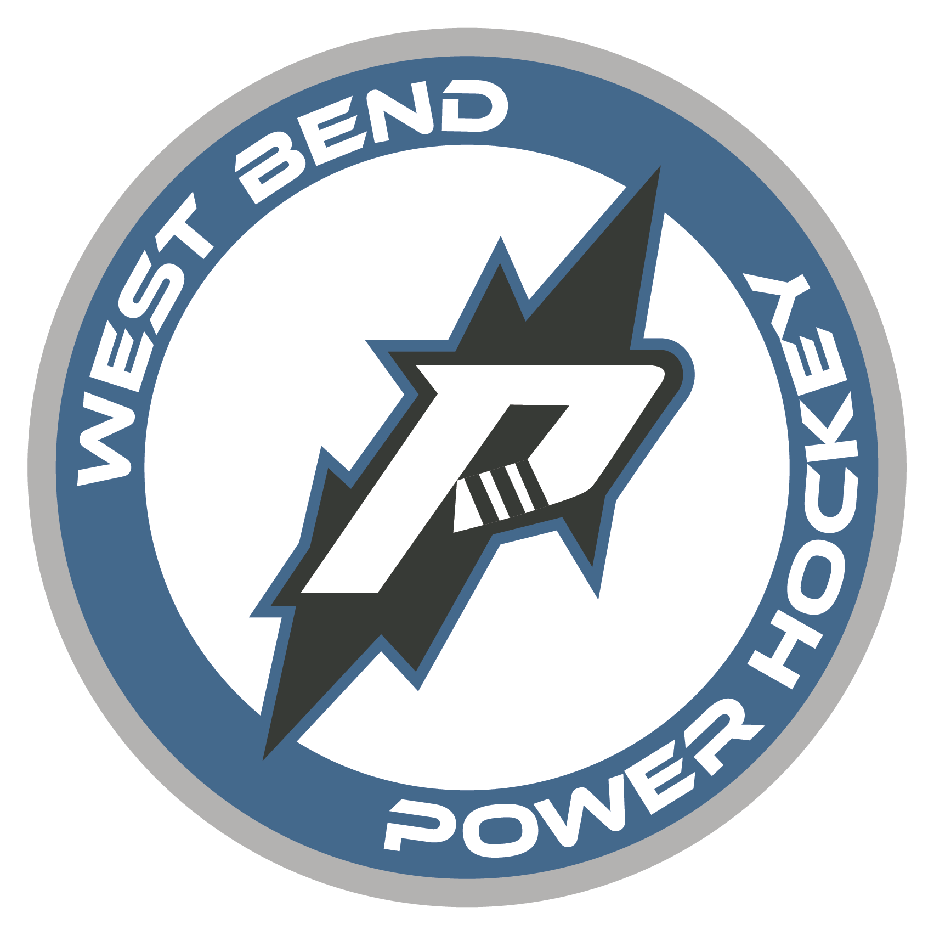
West Bend Power, North American 3 Hockey League
Part Time & Full Time
Offseason (April-Sept) Half-Season (Sept-Dec; Jan-April) Full Season (Sept-April)
The West Bend Power Hockey Organization is looking for motivated, passionate interns to assist with operations during the 2024-2025 season. Power internships are full-time or part-time and allow students the opportunity to gain valuable work experience within a sports organization through hands-on experience. A successful applicant will demonstrate strong organizational skills along with initiative, resourcefulness, and an ability to collaborate with team members for the achievement of team goals. School credit is available in accordance with school and program qualifications.

Multimedia/Broadcast Internship Opportunities:
- Broadcast Camera Operator
- Home Game Videographer
- Home Game Photographer
- Team Correspondent (intermission and post-game interviews)
- Stadium Announcer/DJ

Responsibilities
  - Development of Multimedia creative content
    - Video Editing
    - Graphic Design
    - Photo Editing
  - Assist in creating in-house video content for website and social media.
  - Assist in creating handouts, fliers, promo graphics, etc.
  - Assist in maintenance of team website and social media accounts.
  - Facilitate cross-promotional messaging for corporate partners.
Qualifications
  - Strong knowledge of Adobe Creative Suite
  - Creative mind to consistently find opportunities to create content.
  - Self-starter and highly motivated
To apply please send cover letter and resume to: Kris@westtbendhockey.com

