SPORTS INTERNSHIP OPPORTUNITY
Game Operations Internship
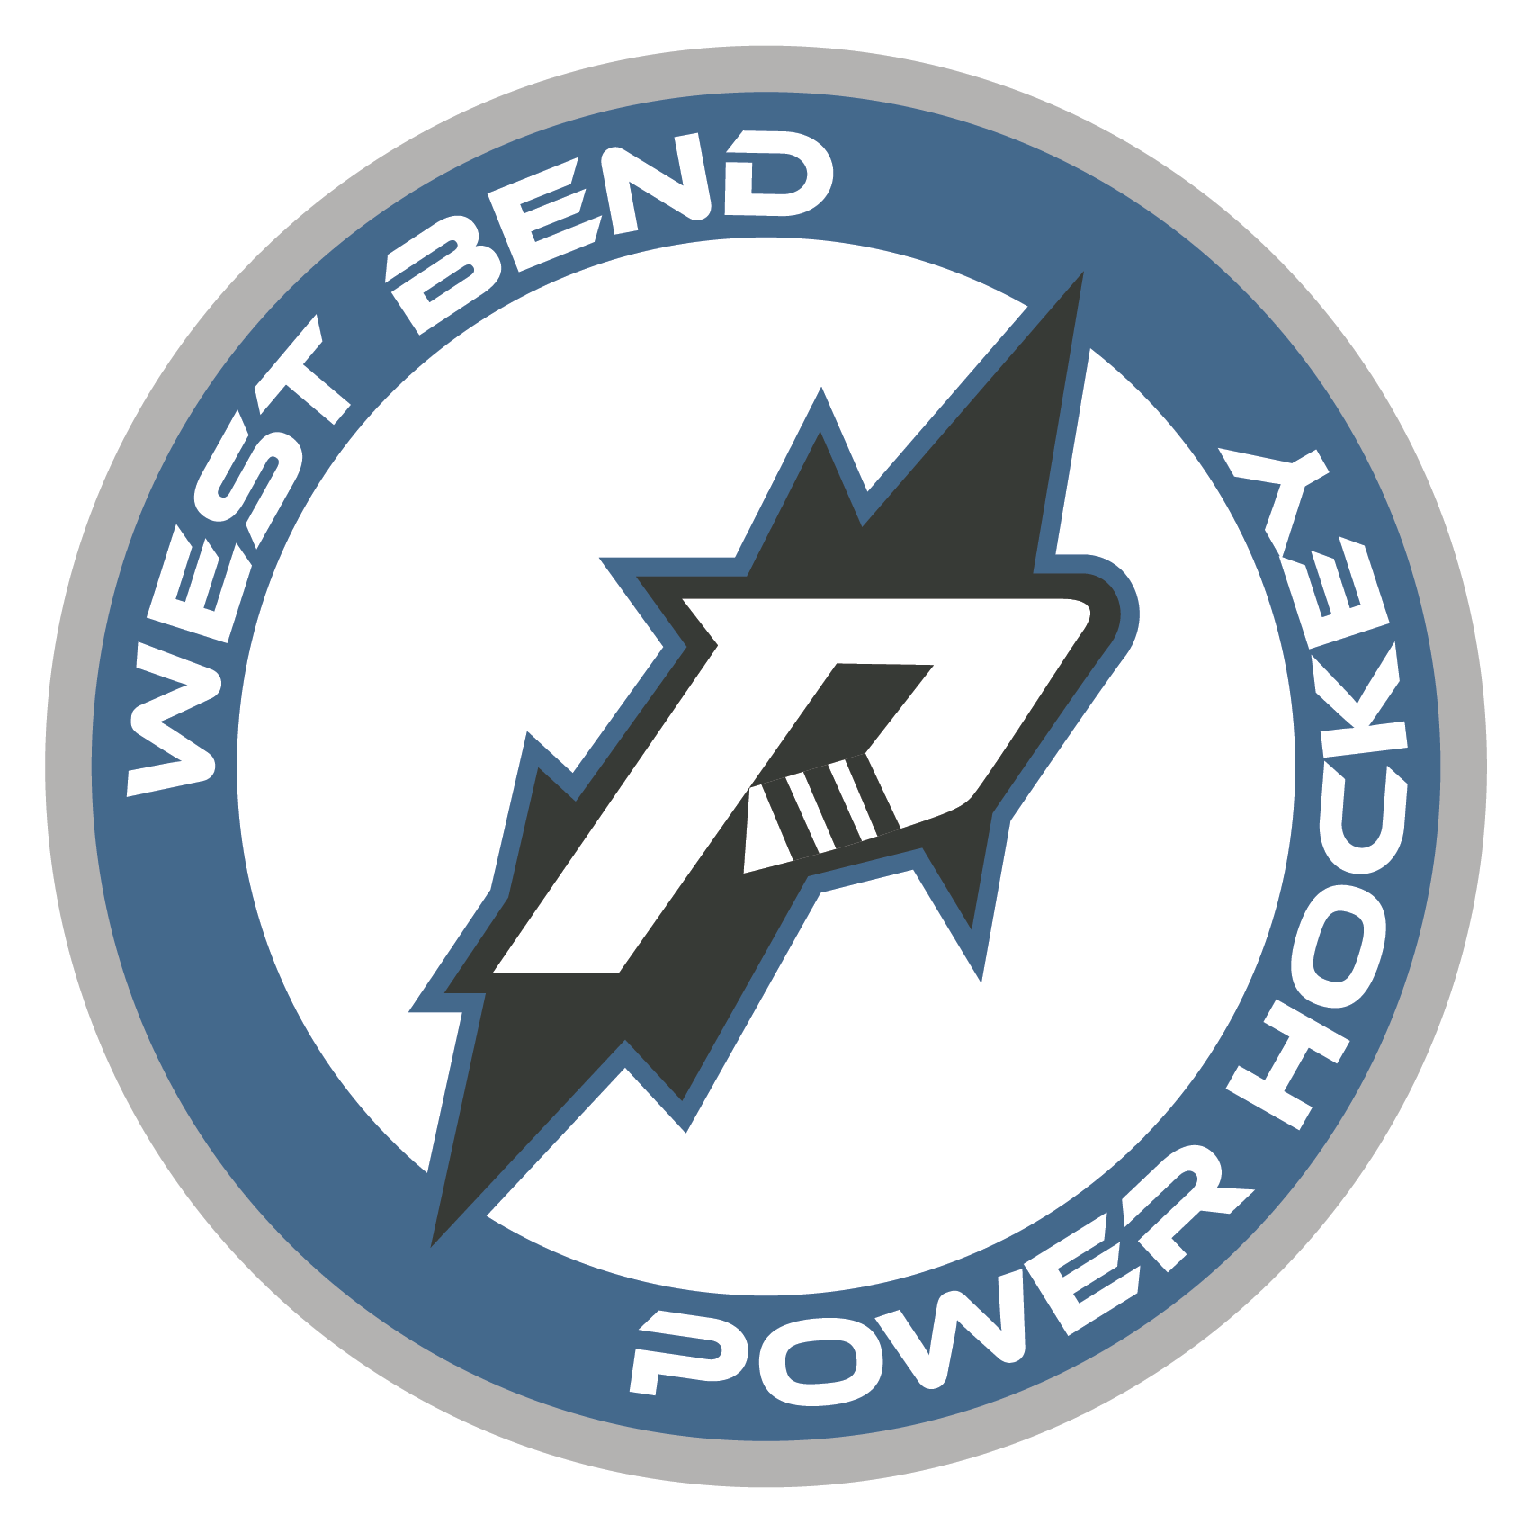
West Bend Power, North American 3 Hockey League
Part Time Half-Season (Sept-Dec; Jan-Mar) Full Season (Sept-Mar)
The West Bend Power Hockey Organization is looking for motivated, passionate interns to assist with operations during the 2024-2025 season. Power internships are full-time or part-time and allow students the opportunity to gain valuable work experience within a sports organization through hands-on experience. A successful applicant will demonstrate strong organizational skills along with initiative, resourcefulness, and an ability to collaborate with team members for the achievement of team goals. Career mentoring is a central aspect of the Powers internship program. School credit is available in accordance with school and program qualifications.
Game Operations Internship
Fan Experience, Game Presentation, Live Entertainment
Responsibilities
  - Prepare and operate merchandise store.
  - Conduct sound check/run through with live entertainment (anthem singer, choirs, color guard, etc.)
  - Assist with live promotional giveaways.
  - Enthusiastically interact with fans during live promotional giveaways
  - Assist with taking tickets at the gate.
  - Review game script and prepare game day materials.
  - Work alongside game presentation team to ensure proper timing for promotions and presentations.
  - Assist with post-game cleanup and organization.
  - Option to work other Power events held during the year.
Qualifications
  - Strong communication skills
  - Ability to multi-task in a fast-paced environment

To apply please send cover letter and resume to: Kris@westbendhockey.com

